DR. NILIMA WAHEGAONKAR

+91 9730365498
Annual Quality Assurance Report (AQAR) for the year: 2015-16

 |  | Part – A
1. Details of the Institution
1.1 Name of the Institution |  | VASANTRAO NAIK MAHAVIDYALAYA
1.2 Address Line 1 |  | CHIKALTHANA ROAD
Address Line 2
City/Town |  | AURANGABAD
State |  | MAHARASTRA
Pin Code |  | 431 003
Institution e-mail address |  | naikcollege@rediffmail.com
Contact Nos. |  | 0240 2482321

Name of the Head of the Institution:

Tel. No. with STD Code:

Mobile:

Name of the IQAC Co-ordinator:

PROF. DR. MILIND UBALE

Page1

Mobile: | +91 9850040964

vnma_iqac@rediffmail.com
IQAC e-mail address:

1.3 NAAC Track ID) | EC_52_RAR_19 dated28-03-2010-Vasantrao Naik College, Aurangabad-
 | Maharashtra.doc

1.4 NAAC Executive Committee No. & Date:
(For Example EC/32/A&A/143 dated 3-5-2004.
This EC no. is available in the right corner- bottom ^{EC/52/RAR/19 dated 28.03.2010} of your institution’s Accreditation Certificate)

www.naikcollege.org
1.5 Website address:

_{Web-link of the AQAR:} http://www.naikcollege.org/aqar.html

For ex. http://www.ladykeanecollege.edu.in/AQAR2012-13.doc 1.6 Accreditation Details

 | Sl. No. | Cycle | Grade | CGPA |  | Year of |  |  | Validity
 |  |  |  |  |  | Accreditation |  |  | Period
 | 1 | 1st Cycle | B | -- | 2003 |  |  |  | 5 years
 | 2 | 2nd Cycle | B | 2.70 | 2010 |  |  |  | 5 years
 | 3 | 3rd Cycle
 | 4 | 4th Cycle
1.7 Date of Establishment of IQAC :
 |  |  |  |  |  | 01/03/2004
1.8 AQAR for the year (for example 2010-11) |  |  |  |  |  | 2015-16

1.9 Details of the previous year’s AQAR submitted to NAAC after the latest Assessment and Accreditation by NAAC ((for example AQAR 2010-11submitted to NAAC on 12-10-2011)

Page2

i. | AQAR | 2010-11 | 23/09/2011
ii. | AQAR | 2011-12 | 07/ 12/2012
iii. | AQAR | 2012-13 | September 2013
iv. | AQAR | 2013-14 | September 2014
v. | AQAR | 2014-15 | September 2015

1.10 Institutional Status
University |  |  |  |  |  | State |  |  |  |  |  |  | Central |  |  |  |  |  |  |  |  |  |  | Deemed |  |  |  |  |  |  |  | Private
 |  |  |  |  |  |  |  |  |  | √
Affiliated College |  |  |  |  |  | Yes |  |  |  |  |  |  | No
 |  |  |  |  |  |  |  |  |  | √
Constituent College |  |  |  |  |  | Yes |  |  |  |  |  |  | No |  |  |  | √
Autonomous college of UGC |  |  |  |  |  | Yes |  |  |  |  |  |  | No |  |  |  | √
Regulatory Agency approved Institution |  |  |  |  |  |  |  |  |  |  |  |  | Yes |  |  |  |  |  |  |  |  |  | No |  |  |  | √
(eg. AICTE, BCI, MCI, PCI, NCI)
 |  |  |  |  |  |  |  |  |  | √
Type of Institution |  |  |  | Co-education |  |  |  |  |  |  |  |  | Men |  |  |  |  |  |  |  |  | Women
 |  |  |  | Urban |  |  |  |  |  | √ |  |  | Rural |  |  |  |  |  |  |  |  | Tribal
Financial Status |  |  |  | Grant-in-aid |  |  |  |  |  | √ |  |  | UGC 2(f) |  |  |  |  |  |  |  |  | √ |  |  | UGC 12B |  |  |  |  |  |  | √
 |  |  |  | Grant-in-aid + Self Financing |  |  |  |  |  |  |  |  |  |  |  |  |  |  |  |  |  | Totally Self-financing
 |  |  |  |  |  |  |  |  |  |  |  |  |  |  |  |  |  | √ |  |  |  |  |  |  |  |  |  |  |  |  |  |  |  | -
 |  |  |  |  |  |  |  |  |  |  |  |  |  |  |  |  |  |  |  |  |  |  |  |  |  |  |  |  |  |  |  |  |  | --
1.11 Type of Faculty/Program
Arts |  | √ |  | Science |  | √ |  | Commerce |  |  |  |  |  | √ |  |  |  | Law |  |  |  |  |  |  |  |  |  | PEI (Phys Edu)
TEI (Edu) |  |  |  | Engineering |  |  |  |  |  | Health Science |  |  |  |  |  |  |  |  |  |  |  |  |  |  |  |  |  | Management
 |  |  |  |  |  |  |  |  |  |  |  |  |  |  |  |  |  |  |  |  |  |  |  |  |  |  |  |  |  |  |  |  |  |  | √
Others | (Specify) |  |  |  |  | -
1.12 Name of the Affiliating University (for the Colleges) |  |  |  |  |  |  |  |  |  |  |  |  |  |  |  |  |  |  |  |  | Dr. Babasaheb Ambedkar Marathwada
 |  |  |  |  |  |  |  |  |  |  |  |  |  |  |  |  |  |  |  |  | University, Aurangabad, M S.

Page3
1.13 Special status conferred by Central/ State Government-- UGC/CSIR/DST/DBT/ICMR etc

Autonomy by State/Central Govt. / University
N/A

 | University with Potential for Excellence |  |  |  | UGC-CPE |  |  |  |  |  | N/A
 |  |  | N/A
 | DST Star Scheme |  |  |  | UGC-CE
 |  |  | N/A |  |  |  |  |  |  |  | N/A
 |  |  | Remedial
 | UGC-Special Assistance Program |  |  |  | DST-FIST |  |  |  |  |  | N/A
 |  |  | Coaching
 | UGC-Innovative PG programs |  | N/A |  | Any other (Specify) |  |  |  |  |  | ---
 | UGC-COP Programs |  | ---
2. IQAC Composition and Activities
2.1 | No. of Teachers |  | 07
2.2 | No. of Administrative/Technical staff |  | 02
2.3 | No. of students |  | --
2.4 | No. of Management representatives
 |  |  | 03
2.5 | No. of Alumni
 |  |  | --
2. 6 No. of any other stakeholder and
 |  |  | --
 | community representatives
2.7 | No. of Employers/ Industrialists
 |  |  | --
2.8 | No. of other External Experts |  | 02
2.9 | Total No. of members
 |  |  | 14
2.10 No. of IQAC meetings held |  | 04

Page4

2.11 No. of meetings with various stakeholders: |  | No. | --- |  | Faculty |  | 04
Non-Teaching Staff Students |  | Alumni |  |  | Others
 | --- |  | --- |  |  |  | ---

2.12 Has IQAC received any funding from UGC during the year? Yes |  |  | √ | No
If yes, mention the amount | 3, 00,000/-

- Seminars and Conferences (only quality related)

  - No. of Seminars/Conferences/ Workshops/Symposia organized by the IQAC

Total Nos. | 0 | International | --- | National | --- | State | 01 | Institution Level | 01

1. “Notions and Innovation: Role of ICT in Higher Education.
(ii) Themes
2. Preparations for NAAC peer team visit

2.14 Significant Activities and contributions made by IQAC

1. Faculty members were motivated to undertake research projects. Major and minor research projects were submitted to UGC and University. Teachers were inspired to pursue research by registering for Ph.D. degree.

2. A one day institutional workshop was conducted.

3. A regional 7 days long short term course was completed.

4. Students were deputed to participate in poster and research paper presentations. 5. MoUs were signed with four research centres to promote collaborative research.

6. A compilation of all the academic and non-academic articles published by the faculty members was done.

2.15 Plan of Action by IQAC/Outcome

The plan of action chalked out by the IQAC in the beginning of the year towards quality

enhancement and the outcome achieved by the end of the year *

Page5

 | Plan of Action |  | Achievements
1. | Organization of seminars and | 1. | 7 day Workshop on ‘Notions and
 | workshops. |  | Innovation: Role of ICT in Higher
 |  |  | Education’ (2nd to 7th Nov. 2015),
 |  |  | And a 1 day workshop on ‘Preparing for
 |  |  | NAAC Peer team Visit’ (11.07.2015).
2. | Promoting research. | 2. | One project (UGC) in Mathematics was
 |  |  | sanctioned. One project in Library science
 |  |  | was sanctioned by the University.
3. | Persuasion for getting Chemistry | 3. | Dr. BAM University approved the Chemistry
 |  |  | laboratory as research centre.
 | research lab recognised.
 |  | 4. | 01 faculty attended refresher course and 08
4. | Teachers’ training.
 |  |  | completed short term course,
5. | Participation in conferences, | 5. | In all 52 seminar/conferences were attended
 |  |  | by the faculty, about 47 articles were
 | publication of articles, books etc.
 |  |  | presented, 58 papers and 05 text books were
 |  |  | published, 05 members contributed as
 |  |  | resource persons.
6. | Establishment of a Central Research | 6. | Steps are being taken.
 | Facility Centre. | 7. | One lecture was organized.
7. | Organization of guest lectures.
 |  | 8. | Seminar competitions, wall magazines etc
8. | Special programs for students by
 |  |  | were organized.
 | science forum and clubs.
 |  | 9. | Office bearers were nominated and
9. | Registration of alumni association.
 |  |  | persuasion for the process of registration is
 |  |  | under process.
10. | MOUs may be established with | 10. | Analytical Chemistry Teachers and
 |  |  | Researchers Association, Aurangabad
 | various research institutes, industries.
 |  |  | (ACTRA), Shiv Chhatrapati Collge Kannad,
 |  |  | and Fergusson College, Pune

* Attached Academic Calendar of the year as Annexure- 1 a, b, c, d & e

2.15 Whether the AQAR was placed in statutory body |  |  |  |  | Yes |  |  |  | No |  | √
Management |  | Syndicate |  |  | Any other body
Provide the details of the action taken |  |  |  |  | --

Page6
Part – B

Criterion – I

1. Curricular Aspects

1.1 Details about Academic Programs

 | Number of | Number of | Number of | Number of value
Level of the |  |  |  | added / Career
 | existing | programmes added | self-financing
Programme |  |  |  | Oriented
 | Programmes | during the year | programmes
 |  |  |  | programmes
PhD | 04 | 02 | - | -
PG | 02 | - | 02 | -
UG | 05 | - | 02 | -
PG Diploma | - | - | - | -
Advanced Diploma | - | - | - | -
Diploma | - | - | - | -
Certificate | - | - | - | -
Others | - | - | - | -
Total | 11 | 02 | 04 | -
Interdisciplinary | - | - | - | -
Innovative | - | - | - | -

- (i) Flexibility of the Curriculum: Elective option √

  - Pattern of programs:

 |  | Pattern |  |  |  |  |  | Number of programmes
 |  | Semester |  |  |  |  |  | 07
 |  | Trimester |  |  |  |  |  | ---
 |  | Annual |  |  |  |  |  | ---
1.3 Feedback from stakeholders* | Alumni |  |  |  |  | Parents |  |  | Employers | --- | Students | √
(On all aspects)
Mode of feedback : | Online |  |  |  |  | Manual
 |  |  | -- |  |  |  |  | √ | Co-operating schools (for PEI) |  |  |  | --

*Please provide an analysis of the feedback in the Annexure

1.4 Whether there is any revision/update of regulation or syllabi, if yes, mention their salient aspects.

N/A

Page7
1.5 Any new Department/Centre introduced during the year. If yes, give details.

NO

Criterion – II

II. Teaching, Learning and Evaluation

2.1 | Total No. of | Total |  | Asst. Professors |  | Associate Professors |  | Professors | Others
permanent faculty
 |  | 29 |  | 20 |  | 08 |  | 01 | ---
2.2 | No. of permanent faculty with Ph.D. |  |  |  | 16

2.3 No. of Faculty Positions Recruited (R) and Vacant (V) during the year

Asst. |  | Associate |  | Professors |  | Others |  |  | Total
Professors |  | Professors
R | V | R | V | R | V | R |  | V | R | V
-- | -- | -- | -- | 01 | 01 | -- |  | -- | 07 | 01

2.4 | No. of Guest and Visiting faculty and Temporary faculty |  |  |  |  |  | Guest → |  |  |  | Temporary→ 09
2.5 | Faculty participation in conferences and symposia:
 |  | No. of Faculty | International level | National level |  |  |  | State level |  | University
 |  |  |  |  |  |  |  |  |  | level
 |  | Attended | -- | -- |  |  |  | -- |  | 20
 |  | Presented papers | -- | 35 |  |  |  | 12 |  | --
 |  | Resource Persons | -- | 03 |  |  |  | 12 |  | --

- Innovative processes adopted by the institution in Teaching and Learning:

  - Use of audio-visual aids

  - Discussions on latest concepts & information in classroom

2.7 | Total No. of actual teaching days
 | during this academic year
2.8 | Examination/ Evaluation Reforms initiated by
 |  |  |  | ---
 | the Institution (for example: Open Book Examination, Bar Coding,

Page8
Double Valuation, Photocopy, Online Multiple Choice Questions)

2.9 No. of faculty members involved in curriculum | BOS- 02
restructuring/ revision/ syllabus development
as member of Board of Study/Faculty/Curriculum
Development workshop

2.10 Average percentage of attendance of students |  |  |  |  |  | 75%
2.11 Course/Program wise distribution of pass percentage:
 | Attached separately as |  |  | Annexure - 2
 | Title of the | Total no. of |  |  |  |  | Division
 |  | students
 | Programme
 |  | appeared
 |  |  |  | Distinction % |  | I % |  |  | II % | III % | Pass %

2.12 How does IQAC Contribute/Monitor/Evaluate the Teaching & Learning processes:

1. Academic Annual Plan of every faculty member is procured in the beginning of the year.

2. Report on topics covered and percent syllabus completed is procured monthly.

3. To improve the academic performance of the students “Tutor Ward” mechanism was helpful.

2.13 Initiatives undertaken towards faculty development: - Faculty members are timely sent for orientation and refresher courses. They are inspired to attend trainings and workshops on syllabii. The members of BOS help to convey the suggestions regarding changes and innovations in the syllabus.

Faculty / Staff Development Programmes | Number of faculty
 | benefitted
Refresher courses | 01
UGC – Faculty Improvement Programme | --
HRD programmes | --
Orientation programmes | --
Faculty exchange programme | --
Staff training conducted by the university | --
Staff training conducted by other institutions | 01
Summer / Winter schools, Workshops, etc. | 09
Others | --

Page9
2.14 Details of Administrative and Technical staff

Category | Number of | Number of | Number of | Number of
 | Permanent | Vacant | permanent | positions filled
 | Employees | Positions | positions filled | temporarily
 |  |  | during the Year
Administrative Staff | 60 | -- | -- | --
Technical Staff | 23 | 06 | 06 | --

Criterion – III

3. Research, Consultancy and Extension

3.1 Initiatives of the IQAC in Sensitizing/Promoting Research Climate in the institution

Faculty is regularly inspired to involve in research activity, attend seminar & conferences, present their research work and publish the work in renowned journals. They are inspired to submit research proposals to financing bodies like, University, UGC, DST etc. Researchers are inspired to conduct research on social issues. The research articles published by the faculty members are compiled and made readily available for reference

3.2 | Details regarding major projects
 |  |  | Completed |  | Ongoing |  |  | Sanctioned |  | Submitted
 | Number |  |  | -- |  | 01 (DST) |  | -- |  | --
 | Outlay in Rs. Lakhs |  |  |  | Rs. 23.08 Lakhs |  |  | -- |  | --
3.3 | Details regarding minor projects
 |  | Completed |  |  |  | Ongoing |  |  | Sanctioned | Submitted
 | Number |  |  | -- |  | 02 |  |  | -- | --
 | Outlay in Rs. Lakhs |  |  | -- |  | 1.20 Lakhs |  |  | -- | --
 |  |  |  |  |  | 1.60 Lakhs
3.4 | Details on research publications
 |  |  |  |  |  | International |  |  | National | Others (News
 |  |  |  |  |  |  |  |  |  | Paper)
 | Peer Review Journals |  |  |  |  |  |  |  |  | 05
 |  |  |  |  | 22
 | e-Journals
 |  |  |  |  |  |  |  |  |  |  | 10Page
 | Non-Peer Reviewed Journal |  |  |  | -- |  |  | -- |  | --
 | Conference proceedings |  |  |  | 06 |  |  |  |  | --
3.5 Details on Impact factor of publications:

Range | 0-5 | Average | 01 | h-index |  | Nos. in SCOPUS

3.6 Research funds sanctioned and received from various funding agencies, industry and other organizations

 | Nature of the Project | Duration |  | Name of the |  |  | Total grant | Received
 |  | Year |  | funding Agency |  |  | sanctioned
 | Major projects | 3 | 23,0800 |  |  |  | DST, New | 12,00000/-
 |  |  |  |  |  |  | Delhi
 | Minor Projects | 2 YRS | UGC (WRO)Pune |  |  |  | 1,20000/- |  | 90,000/-
 |  | 2 YRS | UGC (WRO)Pune |  |  |  | 1,60000/- | 1,20,000/-
 | Interdisciplinary Projects | -- |  |  | -- |  | -- |  | --
 | Industry sponsored | -- |  |  | -- |  | -- |  | --
 | Projects sponsored by the | -- |  |  | -- |  | -- |  | --
 | University/ College
 | Students research
 | projects | -- |  |  | -- |  | -- |  | --
 | (other than compulsory by
 | the University)
 | Any other(Specify) | -- |  |  | -- |  | -- |  | --
 | Total |  |  |  |  |  | 25,88,000/- | 14,10,000/-
3.7 No. of books published i) With ISBN No. |  |  |  |  |  | Chapters in Edited Books
 |  |  |  | 04 |  |  |  |  |  | 23

 |  | ii) Without ISBN No. |  |  |  |  |  |  |  | --
3.8 No. of University Departments receiving funds from
 | UGC-SAP |  |  |  | CAS |  |  |  |  | DST-FIST |  | --
 |  |  | -- |  |  |  |  | ---
 | DPE |  |  |  |  |  |  |  |  | DBT Scheme/funds
 |  |  | -- |  |  |  |  |  |  |  |  | --
3.9 For colleges | Autonomy |  | -- |  | CPE |  |  | -- |  | DBT Star Scheme |  | --
 | INSPIRE |  | -- |  | CE |  |  | -- |  | Any Other (specify) |  | --
3.10 Revenue generated through consultancy
 |  |  |  |  | --

Page11

3.11 No. of conferences | Level | International | National | State | University | College
 | Number | -- | -- | 01(STC) | 01(Workshop) | --
organized by the | Sponsoring | -- | -- | -- | NAAC | --
Institution | agencies

3.12 | No. of faculty served as experts, chairpersons or resource persons → 15
3.13 | No. of collaborations |  |  | International | -- | National |  |  | -- | Any other |  |  | --
3.14 | No. of linkages created during this year
 |  |  |  |  | 03
3.15 | Total budget for research for current year in lakhs :
 |  |  |  |  |  |  | --
 |  |  |  |  |  |  |  |  |  |  | ---
From Funding agency |  |  | -- | From Management of University/College
Total
 |  |  | --

 | Type of Patent |  | Number
3.16 No. of patents received this year | National | Applied | --
 |  | Granted | --
 | International | Applied | --
 |  | Granted | --
 | Commercialized | Applied | --
 |  | Granted | --

3.17 | No. of research awards/ recognitions received by faculty and research fellows of the institute in the
year:-
 |  |  | Total |  | International |  | National |  |  |  |  | State |  | University |  |  |  |  | Dist |  |  | College
 |  |  | -- |  | -- |  | -- |  |  |  |  | 02 |  |  | -- |  |  |  | -- |  |  | --
3.18 | No. of faculty from the Institution who are Ph. D. Guides
 |  |  |  |  |  |  |  |  |  |  |  |  |  |  | 09
 | and students registered under them
 |  |  |  |  |  |  |  | 29
3.19 | No. of Ph.D. awarded by faculty from the Institution
 |  |  |  |  |  |  |  |  |  |  |  |  |  |  |  |  | 02
3.20 No. of Research scholars receiving the Fellowships (Newly enrolled + existing ones)
 | JRF |  |  | -- | SRF |  | -- |  |  |  | Project Fellows |  |  |  |  |  | 01 |  |  |  | Any other |  | 01
3.21 | No. of students Participated in NSS events:
 |  |  |  |  |  |  |  |  |  |  |  |  | 150

Page12

 | University level |  | State level | --
 | National level |  | International level
 |  | -- |  |  | --
3.22 | No. of students participated in NCC events:
 | University level |  | State level
 |  | --
 | National level |  | International level
 |  | -- |  |  | --
3.23 | No. of Awards won in NSS:
 | University level |  | State level
 |  | --- |  |  | ---
 | National level |  | International level
 |  | --- |  |  | ---
3.24 | No. of Awards won in NCC:

 |  |  |  | University level |  |  | --- |  |  | State level
 |  |  |  | National level |  |  |  |  |  | International level
 |  |  |  |  |  |  |  | ---
3.25 | No. of Extension activities organized
 | University forum |  |  | College forum
 |  |  | -- |  | --
 | NCC |  |  | NSS |  |  |  |  | Any other
 |  |  | 09 |  | 06 |  |  |  |  |  | ---
3.26 | Major Activities during the year in the sphere of extension activities and Institutional Social
Responsibility

- NSS

---

---

- Organized camps and rallies for social causes like, blood donation, tree plantation, medical checkup, AIDS awareness, environmental awareness etc.

2. .NSS Special Rural Camp for 7 days

- NCC

- Extending social services as tree plantation, Polio awareness program, Blood donation camp, Anti dowry, Anti corruption, Water conservation rallies, mountaineering etc.

- ‘Swacchata Abhiyaan’ on Gandhi Jayanti.

- Display of social theme on the occasion of Republic Day.

Page13
Criterion – IV

4. Infrastructure and Learning Resources

4.1 Details of increase in infrastructure facilities:

Facilities | Existing | Newly created | Source of | Total
 |  |  | Fund
Campus area | 5 acres | -- | -- | 5 acres
Class rooms | 20 | -- | -- | 20
Laboratories | 06 | -- | -- | 06
Seminar Halls | 01 | -- | -- | 01
No. of important equipments purchased | -- | -- | -- | --
(≥ 1-0 lakh) during the current year.
Value of the equipment purchased during | 11.99 | -- | -- | 11.99
the year (Rs. in Lakhs)
Others | -- | -- | -- | --

4.2 Computerization of administration and library

Library Management System Software exists since 2005.

The library services provided are as follows:-

- Data entry of books,

- bar-coding,

- issue-return-renewal-claiming,

- searching (OPAC),

- cataloguing etc

Page14
4.3 Library services:

 |  |  |  |  |  | Existing |  |  | Newly added |  |  |  |  |  |  |  |  | Total
 |  |  |  |  | (2013-2014) |  |  |  | (2014-15)
 |  |  |  |  |  | No. | Value |  | No. |  |  |  | Value |  |  | No. |  |  |  | Value
 |  | Text Books |  |  | 17591 |  | 2047483/- |  | 148 |  |  |  | 25947/- |  | 17739 |  |  |  | 2073430/-
 |  | Reference Books |  |  | 26122 |  | 3312060/- |  | 240 |  |  |  | 54650/- |  | 2636211 |  |  |  | 3366710/-
 |  | Donated Books |  |  | 1149 |  | Donated |  | 46 |  |  |  | Donated |  |  | 95 |  |  |  | Donated
 |  | INFLIBNET
 |  | - ebooks |  |  | 97000+ |  | 25000/- |  | 97000+ |  |  |  | 5000/- |  | 97000+ |  |  |  | 37000/-
 |  | -ejournals |  |  | 6000 |  |  |  | 6000 |  |  |  |  |  | 6000
 |  | -KRC DR.BAMU |  |  | -- |  | --- |  | 45000+ |  |  |  | 7000/-
 |  | (e0database)
 |  | Journals |  |  | 502 |  | 224319/- |  | -- |  |  |  |  | -- |  | 502 |  |  | 224319/-
 |  | Digital Database |  |  |  | 75(CD) | 12410625/- |  | 10 |  |  |  | Online |  |  |  |  |  | 12410625/-
 |  |  |  |  |  |  |  |  | (e-books) |  |  |  | database |  |  | 85
 |  |  |  |  |  |  |  |  |  |  |  |  | maintained
 |  |  |  |  |  |  |  |  |  |  |  |  | in digital
 |  |  |  |  |  |  |  |  |  |  |  |  | liabrary
 |  | CD & Video |  |  | 232 |  | 45000/- |  | 6 |  |  |  |  |  |  | 238 |  |  | 46421/-
 |  | Others |  | (science | 160 |  | 54400/- |  | -- |  |  |  |  |  |  | 160 |  |  | 54440/-
 |  | charts)
4.4 Technology up gradation (overall)
 |  |  |  | Total |  | Computer | Internet |  | Browsing |  |  | Computer |  | Office |  |  | Depart- |  |  | Others
 |  |  |  | Computers |  | Labs |  |  | Centres |  |  | Centres |  |  |  |  | ments
 |  | Existing |  | 148 |  | 02 | BSNL |  | 01 |  | 02 |  |  | 01 |  |  | 03 |  |  | 01
 |  | Added |  | -- |  | -- | -- |  | -- |  | -- |  |  | -- |  |  | -- |  |  | --
 |  | Total |  | 148 |  | 02 |  |  | 01 |  | 02 |  |  | 01 |  |  | 03 |  |  | 01

4.5 Computer, Internet access, training to teachers and students and any other programme for technology Up-gradation (Networking, e-Governance etc.)

- Entire campus connected with BSNL lease line.

- Internet access for student and faculty through library and departments.

- 30 computers upgraded in 2015 – 2016.

- User orientation program to train newly admitted students for operation of library facilities and services / OPAC

Page15

4.6 Amount spent on maintenance in lakhs :
i) | ICT
 |  | 35750/-
ii) | Campus Infrastructure and facilities
 |  | 346460/-
iii) Equipments
 |  | --
iv) | Others
 |  | 188850/-
Total :
 |  | 571060/-

Criterion – V

5. Student Support and Progression

5.1 Contribution of IQAC in enhancing awareness about Student Support Services

Students are made aware of the different facilities available in the college through prospectus, way to SMS and regular counseling.

The tutor- ward mechanism helps assists in identifying slow and advanced learners. Accordingly they are counseled and inspired in academic and extra- curricular development such as, career guidance, guidance for competitive exams etc.

Important days like, Science, Sanskrit, Hindi, Marathi etc. are celebrated to induce subject awareness.

Different clubs are run through which subject related activities like, wallpapers, quiz, essay, elocution, seminar competitions, Lectures by renowned personalities are conducted.

Important days, like, Independence, Republic, University foundation, Marathwada Mukti Sangram, Womens’, Youth, Birth and death anniversary days of great Heroes of India are celebrated to inculcate love and devotion for Nation.

Students’ council plays a role in inculcating leadership qualities, personality and helps in student grievance.

5.2 Efforts made by the institution for tracking the progression

Result analysis is done yearly and teachers are asked to take extra efforts for weak students.

Academic progress of the students is monitored through continuous assessment program.

Remedial coaching classes are conducted in selected subjects for slow learners.

Advanced learners are identified by the tutors and are facilitated for extra reading by providing reference books and giving special assignments.

Page16

5.3 (a) Total Number of students
 |  |  |  |  |  |  |  |  |  |  |  |  |  |  | UG |  |  |  |  |  |  | PG |  |  |  |  |  |  |  |  |  | Ph.D |  |  |  |  | Others
 |  |  |  |  |  |  |  |  |  |  |  |  |  | 1257 |  |  |  |  |  |  | 50 |  |  |  |  |  |  |  |  |  | 40 |  |  |  |  | --
(b) No. of students outside the
 |  |  |  |  |  |  |  |  |  |  |  |  |  |  |  |  |  |  | --
state
 |  | (c) No. of international students
 |  |  |  |  |  |  |  |  |  |  |  |  |  |  |  |  |  |  |  |  |  |  | --
 |  | Men |  |  |  |  | No |  |  |  |  |  |  | % |  |  | Women |  |  |  |  |  |  |  |  |  |  | No |  |  |  | %
 |  |  |  |  |  |  | 851 |  |  |  |  | 65.11 |  |  |  |  |  |  |  |  |  |  |  |  |  |  |  | 456 |  |  |  | 34.48
 |  |  |  | Last Year (2014-15) UG + PG |  |  |  |  |  |  |  |  |  |  |  |  |  |  |  |  |  |  |  |  |  |  |  |  |  |  |  |  |  |  | This Year (2015-16) UG + PG
 | General |  |  | SC |  |  |  |  | ST |  |  |  |  | OBC |  | Physically |  |  |  |  |  |  | Total |  |  |  |  |  | General |  |  |  |  | SC/ |  | OBC |  | Physically |  |  |  |  |  | Total
 |  |  |  |  |  |  |  |  |  |  |  |  |  |  |  | Challenged |  |  |  |  |  |  |  |  |  |  |  |  |  |  |  |  |  | ST/ |  |  |  | Challenged
 |  |  |  |  |  |  |  |  |  |  |  |  |  |  |  |  |  |  |  |  |  |  |  |  |  |  |  |  |  |  |  |  | VJNT
 | 430 |  |  | 386 |  |  |  |  | 123 |  |  |  |  | 496 |  |  | -- |  |  |  |  | 1435 |  |  |  |  |  |  |  |  | 368 |  |  | 765 |  | 174 |  | -- |  |  |  |  |  | 1307
 |  |  |  |  |  |  | Last Year (2013-14) Ph.D |  |  |  |  |  |  |  |  |  |  |  |  |  |  |  |  |  |  |  |  |  |  |  |  |  |  |  | This Year (2014-15) Ph.D
 |  | General |  |  | SC |  |  |  |  |  | ST |  |  |  | OBC |  |  | Physically |  |  |  |  |  |  | Total |  |  |  |  |  | General |  |  |  | SC |  | ST | OBC |  |  | Physically |  |  |  | Total
 |  |  |  |  |  |  |  |  |  |  |  |  |  |  |  |  |  | Challenged |  |  |  |  |  |  |  |  |  |  |  |  |  |  |  |  |  |  |  |  |  |  | Challenged
 |  | 13 |  |  | 10 |  |  |  |  |  | 04 |  |  |  | 04 |  |  | -- |  |  |  |  |  | 31 |  |  |  |  |  |  | 19 |  |  |  | 11 |  | 04 | 06 |  |  | -- |  |  |  | 40
 |  |  | Demand ratio 1:1 |  |  |  |  |  |  |  |  |  |  |  |  |  | --
5.4 Details of student support mechanism for coaching for competitive examinations (If any)
No. of students beneficiaries |  |  |  |  |  |  |  |  |  |  |  |  |  |  |  |  | ---
5.5 No. of students qualified in these examinations |  |  |  |  |  |  |  |  |  |  |  |  |  |  |  |  |  |  |  |  |  |  |  |  |  |  |  |  |  |  | ---
 | NET |  |  |  |  |  | -- |  |  |  |  |  |  |  | SET/SLET |  |  |  |  |  | -- |  |  |  |  |  |  |  | GATE |  |  |  |  | -- |  |  | CAT |  |  |  | --
 | IAS/IPS etc |  |  |  |  |  |  |  |  |  |  |  |  |  | State PSC |  |  |  |  |  |  |  |  |  |  |  |  |  | UPSC |  |  |  |  |  |  |  | Others
 |  |  |  |  |  |  | -- |  |  |  |  |  |  |  |  |  |  |  |  |  | -- |  |  |  |  |  |  |  |  |  |  |  |  | -- |  |  |  |  |  |  | --

5.6 Details of student counseling and career guidance

Career counseling and guidance imparted to about 200 students

Page17

 |  | No. of students benefitted |  | 102
5.7 | Details of campus placement
 |  |  | On campus |  |  |  |  |  | Off Campus
 |  | Number of | Number of Students |  |  |  | Number of |  | Number of Students Placed
 |  | Organizations | Participated |  |  | Students Placed
 |  | Visited
 |  | 04 |  | 208 |  | 102 |  |  | --
5.8 | Details of gender sensitization programmes
 |  |  |  |  |  | --

5.9 Students Activities

- No. of students participated in Sports, Games and other events

State/ University level | 10 |  | National level | -- |  |  | International level | --
No. of students participated in cultural events
State/ University level |  |  | National level |  |  |  | International level
 |  |  |  |  | -- |  |  |  | --
 | 15

- No. of medals /awards won by students in Sports, Games and other events

Sports : State/ University level |  |  |  | College level |  |  | -- |  | International level |  |  | --
Cultural: State/ University level |  |  |  | National level |  |  |  |  | International level
 |  |  | -- |  |  | -- |  |  |  |  |  | --
5.10 Scholarships and Financial Support
 |  |  |  |  | Number of |  |  |  |  | Amount
 |  |  |  |  | students
 | Financial support from Free-ships |  |  |  |  |  |  |  |  | 24540/-
 | Financial support from government |  |  |  |  | 939 |  |  |  | 2134824/-
 | Financial support from other sources |  |  |  |  | -- |  |  |  | --
 | Number of students who received International/ |  |  |  |  | -- |  |  |  | --
 | National recognitions

Page18
- Student organized / initiatives

Fairs | : State/ University level |  | -- |  | National level | -- |  |  | International level |  | --
Exhibition: State/ University level |  |  | -- |  | National level |  | -- |  | International level |  | --
5.12 No. of social initiatives undertaken by the students
 |  |  |  |  |  |  | 03
5.13 Major grievances of students (if any) redressed: |  |  |  |  |  | 00

Criterion – VI

6. Governance, Leadership and Management

6.1 State the Vision and Mission of the institution

Vision:- “Higher education for Socially and Economically Backward Classes”

Mission:- “दरितु ांचेततमिि ज वो” May the darkness of drown-trodden be expelled.

6.2 Does the Institution has a management Information System
--

6.3 Quality improvement strategies adopted by the institution for each of the following:

6.3.1 Curriculum Development

N/A

6.3.2 Teaching and Learning

Teaching-learning activities are conducted as per academic program forwarded by the University and annual teaching plans prepared by the teachers

- Examination and Evaluation

  - As per the norms given by Dr. BAMU, Aurangabad.

  - Regular test and tutorials

Page19
- Research and Development

  - Submission of minor and major projects to funding agencies

  - Participation and presentations in seminars and conferences

  - Publications in renowned journals

  - Publication or editing of text or reference books

  - To provide guidance for research to Doctoral students.

  - To provide expertise to the community in different fields.

- Library, ICT and physical infrastructure / instrumentation

    - Addition of 30 new computers to the computer lab.

- Human Resource Management

--

6.3.7 Faculty and Staff recruitment

Recruitment of staff is to be made according to the regulations of Government of Maharashtra and Dr. BAM University.

6.3.8 Industry Interaction / Collaboration

Industrial visits by science and commerce faculties.

MOUs signed with research laboratories of Fergusson college, Pune, Shiv

Chhatrapati College Kannad and ACTRA by the department of Chemistry.

6.3.9 Admission of Students

Students are admitted according to first come first serve basis taking their merit into consideration and following the roaster.

Admission and counseling committee helps the students in selection of subjects.

Page20

6.4 Welfare schemes for
 |  | Teaching | Grievance cell, Credit Co-op. Society, Consumer Society, Vishakha
 |  |  | Samiti.
 |  | Non teaching | Grievance cell, Credit Co-op. Society, Consumer Society, Vishakha
 |  |  | Samiti.
 |  | Students | Grievance cell, Consumer Society, Vishakha Samiti. Book-bank scheme
6.5 | Total corpus fund generated
 |  |  |  | --
6.6 Whether annual financial audit has been done |  |  |  |  | Yes |  | No
 |  |  |  |  |  | √

6.7 Whether Academic and Administrative Audit (AAA) has been done?

 | Audit Type |  |  | External |  |  |  |  |  |  | Internal
 |  |  | Yes/No |  | Agency |  |  | Yes/No |  |  | Authority
 | Academic |  | -- |  | -- |  |  | Yes |  |  | Management
 | Administrative |  | -- |  | -- |  |  | Yes |  |  | Management
6.8 Does the University/ Autonomous College declare results within 30 days? |  |  |  |  |  |  |  |  |  |  | N/A
 |  | For UG Programmes |  |  | Yes | √ |  | No
 |  | For PG Programmes |  |  | Yes | √ |  | No

6.9 What efforts are made by the University/ Autonomous College for Examination Reforms? |  |  |  |  |  |  | N/A
6.10 | What efforts are made by the University to promote autonomy in the affiliated/constituent colleges?
6.11 | Activities and support from the Alumni Association
 |  |  | ---
6.12 | Activities and support from the Parent – Teacher Association
 |  |  |  |  | ---
6.13 | Development programmes for support staff
 |  | --

N/A

Page21

6.14 Initiatives taken by the institution to make the campus eco-friendly | Tree plantation.

Criterion – VII

- Innovations and Best Practices

  - Innovations introduced during this academic year which have created a positive impact on the functioning of the institution. Give details.

    - Up gradation of the office computer software has made many office operations fast and easy.

  - Provide the Action Taken Report (ATR) based on the plan of action decided upon at the beginning of the year

  - Minutes of the first meeting were discussed with the management and permissions were acquired for infrastructural development.

  - Faculty members were motivated to undertake and publish quality research.

  - Proposals for holding workshops were submitted.

  - Special efforts are being taken for the registration of alumni association.

  - To improve the attendance of the students and their output in the examinations extra efforts are being taken by counselling through tutor-ward mechanism. Students are communicated through Way to SMS.

  - Club activities were planned to promote interest in the respective subject.

  - A new practice to contribute 1 rupee per day by the teaching faculty to help the needy students was discussed and confirmed.

- Give two Best Practices of the institution (please see the format in the NAAC Self-study Manuals)

    - Continuous Reading Activity

    - Financial assistance to students

    - One tree per staff member was planted and taken responsibility of in the campus.

* Details in Annexure- 3

7.4 Contribution to environmental awareness / protection

Tree Plantation.

Page22

7.5 | Whether environmental audit was conducted? | Yes |  | No | √
7.6 | Any other relevant information the institution wishes to add. (for example SWOT Analysis) |  |  |  |  |  | --

- Plans of the institution for the next year:-

  - Infrastructural developments in the college campus.

  - Organization of seminars and conferences.

  - Submission of MRPs to funding agencies.

  - Organization of study tours and industrial visits.

  - Organization of Principal’s address and Bridge course for newly admitted students.

  - Organization of guest lectures.

  - Submission of SSR to NAAC for the third cycle.

DR. NILIMA WAHEGAONKAR PROF. M. B. UBALE, Principal

Signature of Coordinator IQAC Signature of Chairman IQAC

Page23

ANNEXURE – 1-a (Academic Calender)

Calendar for the programs conducted in the college in the year 2014-2015 are planned by the college
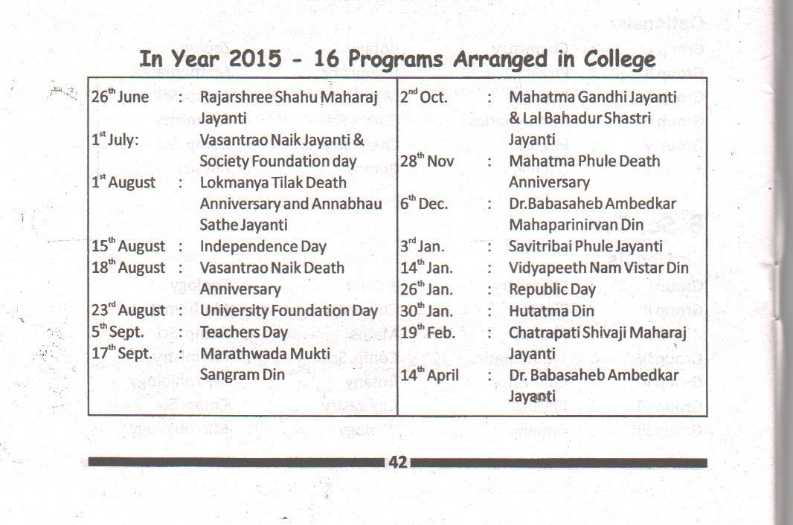

Page24

Academic calendar provided by Dr. Babasaheb Ambedkar Marathwada University, Aurangabad, to which the college is affiliated, is followed. The academic calendar given by Dr. B.A.Marathwada University is attached.

ANNEXURE – 1 (Academic Calender)
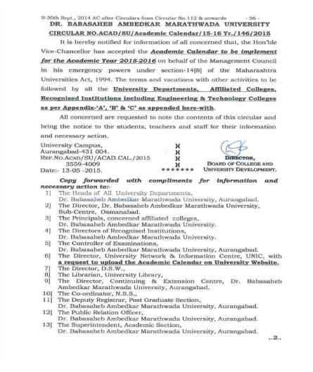

Page25
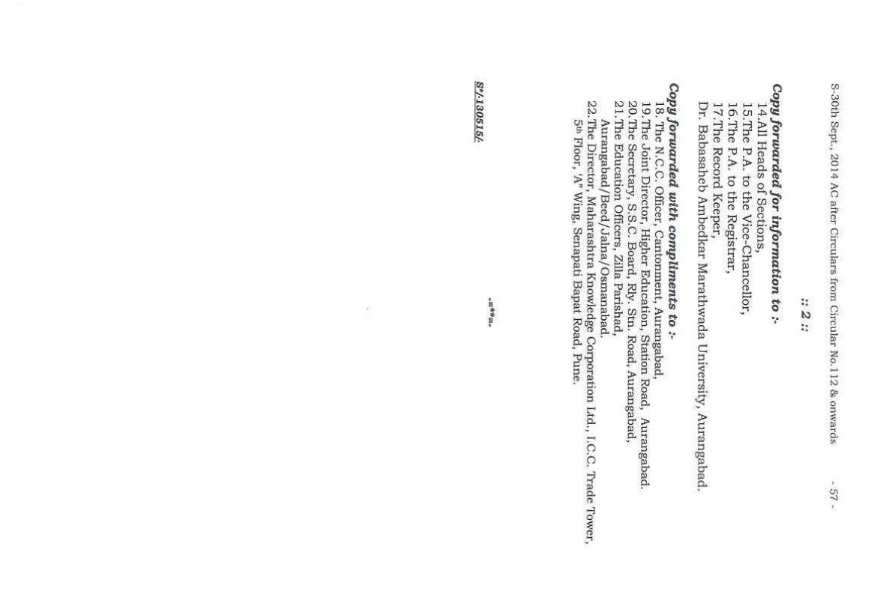

Page26

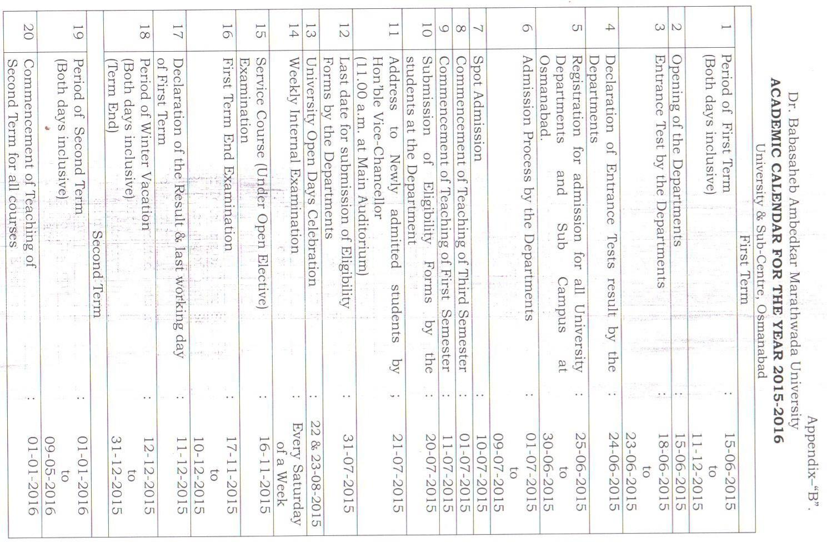

Page27

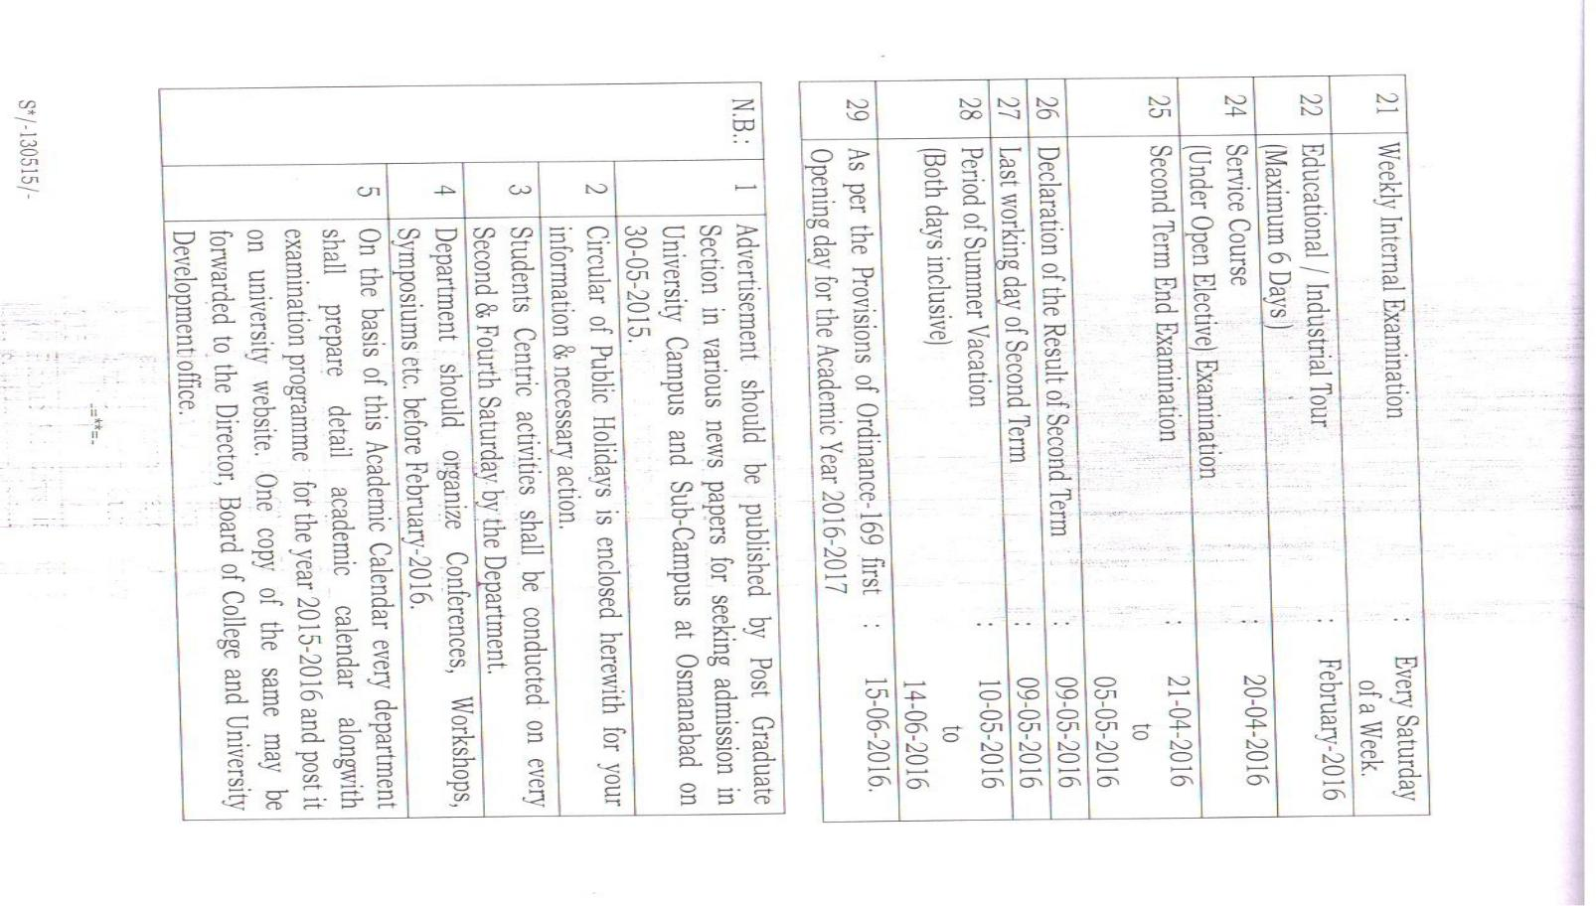

Page28

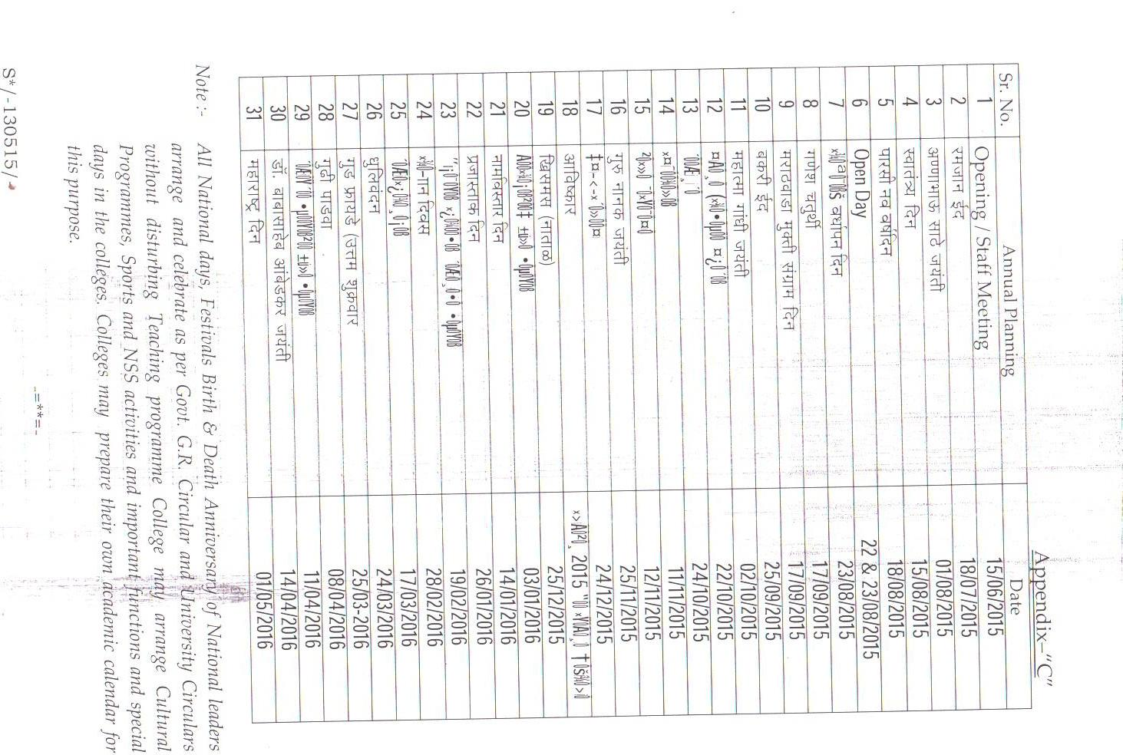

Page29

ANNEXURE – 2

VASANTRAO NAIK MAHAVIDYALAYA , 2015-2016

MARCH/ APRIL-2016 RESULT

SR. | CLASS | TOTAL | STUDENTS | RESULT
NO |  | NUMBER OF | APPEARED |  |  |  |  | PASS
 |  | STUDENTS |  |  |  |  |  | PERCENTAGE
 |  |  |  | PASS |  | ATKT | FAILED
1 | B.A.F.Y. | 225 | 131 | 57 |  | 59 | 15 | 43.51%
2 | B.A.S.Y. | 117 | 100 | 17 |  | 85 | 32 | 12.68%
3 | B.A.T.Y. | 91 | 82 | 21 |  | 0 | 60 | 25.92%
4 | B.COM.F.Y. | 118 | 111 | 43 |  | 55 | 13 | 38.73%
5 | B.COM.S.Y. | 110 | 105 | 50 |  | 41 | 14 | 47.61%
6 | B.COM.T.Y. | 73 | 66 | 27 |  | 0 | 39 | 40.90%
7 | B.Sc.F.Y. | 134 | 112 | 27 |  | 63 | 22 | 24.10%
8 | B.Sc.S.Y. | 87 | 86 | 10 |  | 48 | 26 | 11.90%
9 | B.Sc.T.Y. | 78 | 73 | 6 |  | 0 | 67 | 8.21%
 | TOTAL | 1033
10 | B.C.S.F.Y. | 62 | 50 | 41 |  | 7 | 2 | 82.00%
11 | B.C.S.S.Y. | 48 | 41 | 4 |  | 17 | 20 | 9.75%
12 | B.C.S.T.Y. | 14 | 13 | 9 I DIV |  | 0 | 4 | 69.23%
13 | B.C.A. F.Y. | 43 | 30 | 22 |  | 1 | 7 | 73.33%
14 | B.C.A. S. Y. | 38 | 32 | 14 |  | 15 | 3 | 43.75%
15 | B.C.A..T.Y. | 19 | 18 | 9 |  | 0 | 9 | 50.00%
 | M.A. ( ENG )
19 | S.Y. | 16 | 14 | 8 |  | 0 | 6 | 57.14%
 | M. Sc.
20 | (Chem) F.Y. | 25 | 22 | 2 |  | 20 | 0 | 9.90%
 | M. Sc.
21 | (Chem) S.Y. | 9 | 6 | 1 |  | 0 | 5 | 16.66%
 | TOTAL |  |  | 274

Page30

ANNEXURE – 3 – 1 (Best practice)

Continuous Reading Activity

Aim: To instill and encourage reading habit among the students.

Seeking inspiration from the 125th birth anniversary of Dr. Babasaheb Ambedkar the institution has introduced continues 18 hours reading activity for staff and students. A lecture series was organized on the occasion of the 125th birth anniversary along with a book exhibition displaying books authored by Dr. Babasaheb Ambedkar and those related to his biography. Over 20 students and a few teaching and non-teaching staff participated in the continuous reading activity. They expressed their positive views regarding the activity. The activity culminated with essay writing and elocution competitions based on the knowledge acquired during the reading session. The institute plans to pursue the activity every year hereafter. In addition to this to encourage and enhance reading habit among the students the library also organizes a book exhibition on different occasions throughout the year. The purpose of this activity is to acquaint and attract the students and staff to the treasures of the library and new arrivals.

ANNEXURE – 3 – 2 (Best practice)

Financial assistance to students

From the academic year 2015-16 the teaching and non-teaching staff has introduced a unique assistance scheme for the benefit of needy students. Under this scheme every member of the college contributes a rupee per day. The amount thus collected is utilized for giving financial assistance to the needy and deserving students identified by the staff members. This assistance is for paying the tuition and examination fees, purchasing books, uniform, stationery etc.

Page31

